Stanley Morgan
stanley.morgan@gmail.com | +44 1234 567890 | LinkedIn

EDUCATION
University of Trackr  Bachelor of Science: Economics | Bristol, UK  2023 – 2026
- Average Grade: 83% (First Class)

Trackr High School  Secondary Education | Reading, UK  2021 – 2023
- A-Levels: Economics (A*), Mathematics (A*), Physics (A), EPQ (A*)
- Activities: Head Boy (23-24), Football 1st Team

WORK EXPERIENCE
Bank of Trackr  Investment Banking Summer Analyst | London, UK  Jun 2025 – Aug 2025
- Built 5-year discounted cash flow model for £4.2bn SaaS business, used in meeting with sell-side CEO
- Created 11 slides of 45-page presentation for a £2.2bn buy-side acquisition pitch, resulting in secured mandate
- Presented £2.1bn acquisition opportunity of Quantexa to the entire European TMT team; equity story included bolt-on M&A in North America, office expansion into Asia and reducing opex via headcount reduction
- Aggregated 104 precedent transaction multiples in the cybersecurity sector to complete annual market report

Trackr Suisse  Spring Intern | London, UK  Apr 2024
- Attended 6 speaker talks covering UK M&A, ECM, FICC, corporate broking, credit/market risk, and tech
- Achieved 1st place in mock M&A negotiation for British Airways, using trading comps, past financials and industry forecasts to identify implied price of £23.40 per share

J.P. Trackr  Insight Day | London, UK  Oct 2023
- Participated in M&A case study, assessing operational synergies, commercial risks and trading comps
- Attended networking session with 22 investment bankers; discussions included European SPAC market, tariff impacts on technology VC/SMEs, and modelling nuances between LIBOR, SOFR and SONIA

Starbucks  Coffee Barista | Reading, UK  Oct 2022 – Jun 2023
- Recommended and implemented new cash registry software, reducing customer transaction time by 30%
- Mentored 4 junior baristas in latte art and customer service, reducing employee turnover rate by 45%

EXTRACURRICULAR ACTIVITIES
University of Trackr Investment Fund  Investment Analyst – Energy & Infrastructure | Bristol, UK  Oct 2024 – Present
- Produced equity research report for Ørsted A/S with SELL recommendation; report included competitive overview, European supply chain risks and company valuation (DCF, DDM, trading comps)
- Achieved 1st place in stock pitch competition, pitching First Solar Inc; thesis included favourable fixed PPA prices, rising greenfield completion rates, and positive macro-outlook for solar PV NEMs

SKILLS & INTERESTS
Languages: | English (Fluent), Polish (Native), German (Working Proficiency)
Technical Skills: | Python, C++, SQL, HTML/CSS
Certifications: | Bloomberg Market Concepts, J.P. Morgan Virtual Experience
Interests: | Off-piste Snowboarding, Fridge Magnet Designs, Turtle Conservation, Korean History


DELETE THIS PAGE – DO NOT USE A 2-PAGE RESUME
ADDING/REMOVING/EDITING EXPERIENCES
The headers of experiences use tables to ensure correct alignment as shown in the screenshot below.
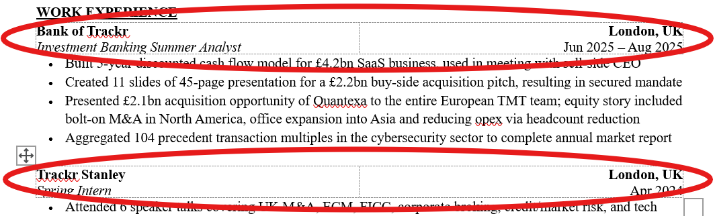
While editing, we highly recommend enabling Table Gridlines. To do this, click on any of the job titles, then navigate to the ‘Table Layout’ tab on the ribbon and select ‘View Gridlines’, as shown below.
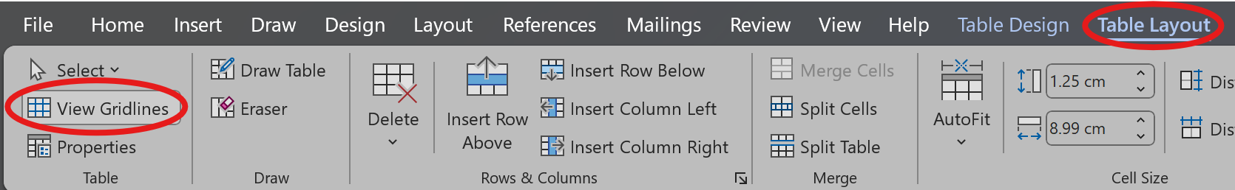
If you choose to add a new experience, you should copy and paste the header from another job to create a new table and then edit the text.
UPDATE LINKEDIN URL
The ‘LinkedIn’ at the top of the resume is a hyperlink. Remember to update the link to your own LinkedIn profile.
